Support of full lifecycle
The organisation
Within this big organisation , the project is happening within a specialized team supporting the whole lifecycle of logistics for mail and parcel delivery. In german it goes for A-Z , ASTVZ
Annahme : Receiving , where parcel and mail is received by the Swiss Post
Sortierung: Sorting, where swiss post separates the received items by destination and decides where to proceede with their handling
Transport: Transport, includes the transport from and to sorting plants and delivery sectors
Verzollung: Customs Clearance, handles the international parcels and letters and the required checks and paperwork going with it
Zustellung: Delivery, is the last step for every item. It is delivered by the many yellow delivery vehicles and their friendly staff of Swiss Post
However, this process is more easily visualized by the future vision of Swiss Post. Especially the one tailored for the IT section fits well to describe the projects environment.
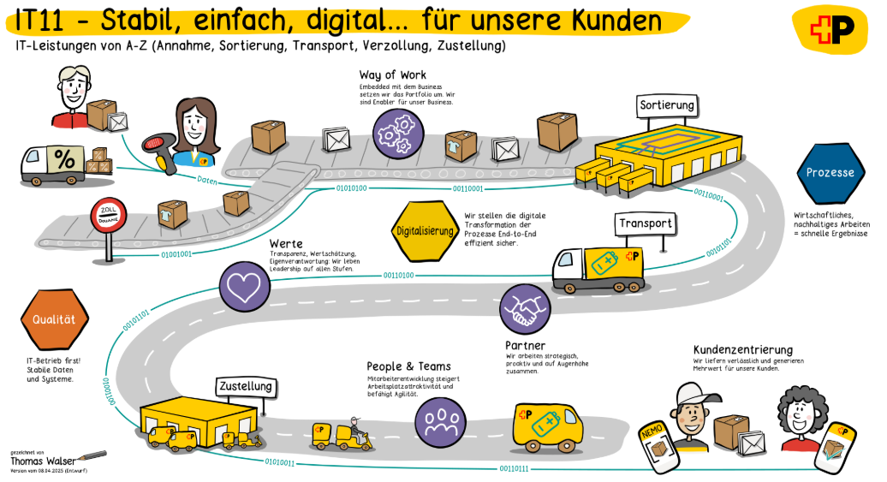
Future way of work displays full postal delivery workflow from receiving and item till delivery.

DWH LS OPS
The project team support the Data warehouse of logistic services operations. The single source of truth when it comes to analytical reporting at Swiss Post. The team handles use cases all over the postal delivery workflow. This project will however first focus on supporting the sorting data flows.
Sorting in Swiss Post is the process of gathering the received items into centralized plants where letters and parcels are sent to from a region of Switzerland. One such plant is located at Härkingen
Picture of Härkingen
The mail pieces are handled by workers and put onto the automated sorting hardware of swiss Post. The hardware which enables the handling of up to 10’000 (TODO , Source) parcels per hour. It will scan the received pieces and let them flow trough the plant to a designated discharge zone.
Bild X
With these innovations including robot automatization such as….
The swiss post was crowned 9times in a row.. best post of the world…

